**String Matching or Sub-string Search**

finding the occurrence or occurrences of a shorter string (sub-string or pattern) within a longer string (text or haystack). The goal is to locate the starting index of the first occurrence of the sub-string in the longer string.

1. **Problem solving:**

**Define Function:**

Create a function named strStr that takes two string parameters, haystack and needle.

**Handle Empty Needle:**

Check if the needle is an empty string. If it is, return 0 since an empty string is always found at index 0.

**Iterate through Haystack:**

Use a loop to iterate through the characters of the haystack.

**Check Substring Match:**

For each position in the haystack, check if a substring of the same length as the needle matches the needle.

**Return Index on Match:**

If a match is found, return the current index.

**Return -1 if No Match:**

If no match is found after iterating through the entire haystack, return -1.

1. **Flow chart**

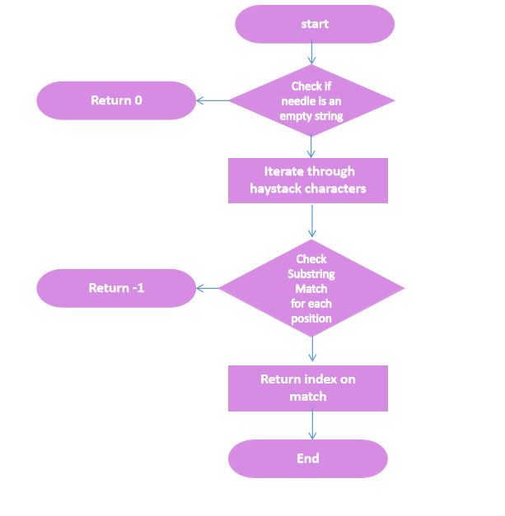

**End**

1. **Output** 